“This program was one of the best investments we have made in our business in a long time. Our standing room only crowd loved The Shef!” Jim Nelson, Owner/Broker Coldwell Banker, Rochester, MN
On (Date, Time)
Discover Why Everyone Is
Raving About Dave “The Shef” Sheffield’s NEW Program, “How to Keep Your Head On…While Working Your Butt Off” by seeing His Program Live

“Some programs you spend time at. This was the best investment of my time I have had in a long time. Motivating, Interactive, and I was given tools to put the strategies to work right away!” -Deb Blimline, Maryland Association of Office Professionals

“I have seen Tony Robbins, Zig Ziglar, all of the greats. The Shef's program was better than anything I have ever been a part of!” Suzanne Nichols, Washington State Workforce Professionals

Investment:
You will Discover: Location: .
- Creating a positive attitude in a negative world.
- The 3 mistakes people make when setting goals
- How to keep going, when you just want to drop!
- Keys of communication, even with difficult people!

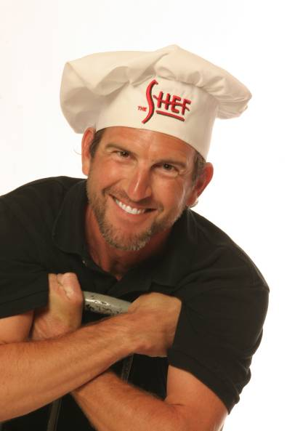
About the presenter:
Dave "The Shef" Sheffield has touched the lives of more than 450,000 people from 58 different countries via his books and energetic live programs. Whether your group is trying to increase sales, decrease staff turnover, or is struggling with change and motivation; The Shef will provide the necessary ingredients for success.
He is the contributing author of 5 top selling books, Unleashing the Leader Within You, When Would NOW be a Good Time?, Unleashing the Vision Within You, One Step From Striking Gold, and A Massive Dose of Motivation. These books have sold in excess of 70,000 copies worldwide!

www.theshef.com
For Additional Information or to RSVP, Please contact:

